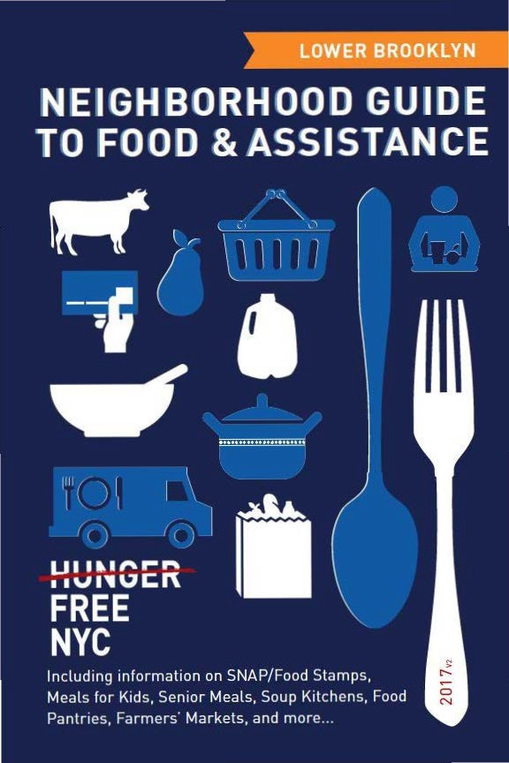

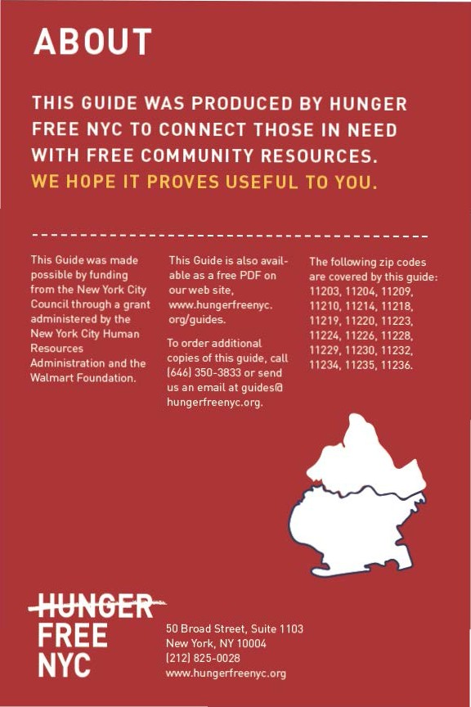

CON TEN TS

Food Stam ps/SNAP 4
6) Food fo r Kids 8
(I) Seni or Meals 1 1
0- Soup Kitchens & Food Pantries 12
e Em ployme nt & Tra ini ng 19
e From the Farm 20
Map of Locations 24
Other Assista nce 30
Emergency N um bers 31

Neighborhood Guide to Food and Assistance - Lower Brooklyn Edition
 SNAP/
FOOD STAMPS
SNAP benefits, the new name for food stamps, can help put healthy food on the table by providing monthly assistance
to purchase food at authorized grocery stores and farmers' markets. Benef its are provided monthly th rough a plastic benef it card, similar to a de bit or credit card.



EBT
Stands for Electronic Benefit Transfer. It's the system the goverment uses to disburse benefits.

SNAP
Stands for
Supplemental Nutrition Assistance Program. "SNAP benefits" is the same thing as ..food stamps."

WHAT SHOULD I KNOW?

ID Employment does not interfere with getting SNAP.Even if you a re working, but earning lowwages, you may be eligible.
ID Average SNAP benefits a re over $100 per person per month, and $250 or more
for families. That mea ns that SNAP benef its for the average family receiving them totals more than $3,000 worth of food support
each year.
ID Farmers' markets often accept SNAP benefits, so you ca n purchase fresh produce and food-producing seeds and plants using your benefits. For a complete list of farmers' markets that accept them , see page 20.

IINeighborhood Guide to Food and Assistance ·Lower Brooklyn Edition

AM I ELIGIBLE?


Eligibilit y is based on household size, income, expenses and other factors. Households have to meet income tests to receive benefits, but households that have members w ho are disabled or elderly (60 or older), or have out-of-pocket expenses for
.
child care or dependant ca re, ca n have higher incomes a nd still be eligible.

NUMBER OF PEOPLE
A
MONTHLY INCOME LIMIT
1
IN HOUSEHOLO | (PRE-TAXES] |  | SNAP BENEFITS
1 | $1 ,307 |  | $192
2 | $1 ,760 |  | $352
3 | $2,213 |  | $504
4 | $2,665 |  | $640

MAX.MONTHLY
2

Each additional household member
+$453
(approximately)
+ $144
(approximately)

11n effect
10/1/16 - 9/30/17.

21n effect
10/1/16 - 9/30/17.

If you meet the above income qualifications, it doesn't matter how much money you may or may not have in countable resources. In other words, you can save money for education , a home purchase, or retirement a nd still receive SNAP benefits.

Neighborhood Guide to Food and Assistance - Lower Brooklyn Edition II

IMMIGRANT ELIGIBILITY

Legal immigrants can often receive SNAP benefits if they:
- have lived in the country for 5 years or more; or
- are children (under age 18).
Ineligible immigrant parents can still receive benefits for their children even if a parent does not qualify.
Certain non-citizens, such as those admitted for humanitarian reasons, may also be able to receive benefits.
Immigration status is not negatively affected if you apply for or receive SNAP benefits.

HOW TO APPLY

Apply at Select Community Organizations
1

Call either of the below numbers to see if you may be eligible for benefits. If so, you’ll be offered an appointment at an agency in your community, where you’ll receive help in submitting your application electronically.
Hunger Free NYC
646 355 1475 & 646 350 1104

Neighborhood Guide to Food and Assistance - Lower Brooklyn edition
6

ACCESSNYC
2
SNAP/FOOD STAMPS

Apply online at: www.nyc.gov/accessnyc

Visit Your Local HRA Office
3

Apply at a SNAP office near you:

1 Coney Island SnAP office
2857-2865 W. 8 St., 1st Floor, 11224
718 722 8013
Mon-Fri 8:30am-5pm

You can also call 718 557 1399 to find a SNAP office near you and for information about qualifications, guidelines, and applications.
I)FOOD FOR KIDS
WOMEN, INFANTS & CHILDREN
WIC is the Women,Infants & Children Program.
QUICK FACTS
ID WIC is for low-income pregnant women, breast-feeding women, and women with children under the age of five.
ID You can work and still get WIC.
ID You can continue to get cash assistance or SNAP benefits/food stamps while receiving WIC.
ID You can get WIC even if you are undocumented or not a citizen.

HOW TO APPLY
To find the WIC off ice nearest you call 800 522 5006, call 866 3-H UN G RY or v isit these local WIC off ices.
- NYU Lutheran - Sunset Terrace WIC 514 49th St.. 11220
718 633 0067
Mon, Tue, Thu, Fri 8am-4:30pm; Wed 8am-6pm
- NYU Lutheran - Family Support Center WIC 6025 6th Ave.. 11220
718 630 7161/8531
Mon, Wed 8am-6pm; Tue 8am-7pm ; Thu, Fri 8am-5pm
- Brooklyn Hospital Center - 61st St Family Health Center 771 61st St., 11220
718 745 3259
Mon-Thu 9am-5pm, Fri 8:30am-4:30pm, every other Sat 9am- 4pm

IINeighborhood Guide to Food and Assistance - Lower Brooklyn Edition
- Maimonides Medical Center wIC 5613 Fort Hamilton Parkway, 11219 718 854 3190
FOOD FOR KIDS
Mon, wed, Thu 7:45am-4:45pm; Tue 7:45am-7pm; Fri 8am-2pm;
3rd Sun 9am-1pm
- Brooklyn Hospital Center - Coney Island
485 Coney Island Ave., 11218
718 282 8904
Mon, wed 11am-6:30pm; Tue, Thu 9am-4:30pm Fri 8:30am- 4:30pm
- yeled v'yalda early Childhood Center (38th St.)
1312 38th St., 11218
718 686 3799
Mon 10:30am-7pm; Tue, wed 8:30am-4:30pm; Thu 7am-3:30pm;
Fri 8:30am-12;30pm; Sun once/month 9am-12pm
- kings County Hospital Center wIC office
451 Clarkson Ave. T Building, Room 153, 11203
718 245 3123
Mon, Tue, Thu 8am-5:30pm; wed 8am-7pm (last appt. at 3:45pm); Fri 8am-5pm (last appt. at 2pm)
- kings County Hospital Center - Church Ave. wIC
4310B Church Ave., 11203 718 282 1702
Mon-wed, Fri 9am-2:30pm; Thu 8am-2:30pm
- kings County Hospital Center - nostrand Ave. wIC
2266 Nostrand Ave., 11210
718 338 2588
Mon-Fri 9am-5pm
- yeled v'yalda early Childhood Center (Farragut rd)
6002 Farragut Rd., 11236
718 943 8812
Tue, wed 10am-5pm
- Coney Island Hospital wIC Program 2601 Ocean Parkway, Room 1N1, 11235 718 616 4338
Mon-Fri 8am-7pm, Sat 9am-4pm
- Public Health Solutions ocean Ave. wIC Center
2555 Ocean Avenue, 2nd Floor, 11229
718 332 4059
Mon 11am-6:30pm, Tue-Fri 8:30am-4pm, alternating Sat and Sun 8:30am-4pm

SCHooL & SUMMer Me ALS

SFSP is the Summer Food Service Program, also known as Summer Meals.
QUICk FACTS
During school, free breakfasts are available to all children regardless of income, with no paperwork required.
Many public school students are also eligible for free or reduced price lunch. An application may be required.
Eligibility for school meals is not impacted by immigration status.
In June, July and August, lunch and breakfast are served for free to all children under 19 at many public schools, houses of worship, recreation centers, and community centers - no application or registration required.
Visit www.schoolfoodnyc.org for more information about school breakfast, school lunch, and summer meals. For nearby summer meals sites, text FOOD to 877-877, call 311, or call the National Hunger Hotline at 866 3-HUNGRY.

Neighborhood Guide to Food and Assistance - Lower Brooklyn edition
10

eSENIOR MEALS
MEALS AT SENIOR CENTERS
Senior centers often serve meals for older people. Some centers offer free meals, oth ers ask for a small contribution !from fifty cents up to a few dollars!. This contribution may be voluntary or required. Senior cen ters and other sites with food for seniors are marked with • in the Soup Kitchens and Food Pantries section.
FIND YOUR LOCAL SENIOR CENTER
Call 311 and be prepared to provide your ZIP code to the operator.

MEALS- ON- WHEELS PROGRAM
If you are homebound and over the age of 60, you can receive home-delivered meals up to 7 days a week. Household income does not
affect eligibility.
HOW TO APPLY
To request meals-on-wheels service , call yourlocal case management agency.
To find the appropriate agency, contac t the Citymeals-on-Wheels' Program Department at 212 687 1234 or the National Hunger Hotline at 866 3-HUNGRY.
Neighborhood Guide to Food and Assistance - Lower Brooklyn Edition

SOUP KITCHENS OFOOD PANTR IES


Ag encies listed as soup kitchens provide prepared meals during
their listed serving times, w hile agencies listed as food pantries provide bags of food to be prepared at home.
While we try to keep this list as accurate and up-to-date as possible, we recommend calling the agency before going to confirm their schedule. Some agencies require a referral, ID, or proof of address. To confirm, contact the agency directly. call the NYC Emergency
Food line at 866 888 8n7 or call the National Hunger Hotline at 866
3HUNGRY. Agencies marked with are senior centers and/or provide food spec1f1cally for seniors.
SUNSET PARK, BAY RIDGE
11232. 11220, 11209
14 Sunset Park Emerg ency Food Program I The Center for Family
lif e
443-39th St., 11220
718 492 3585
Food Pantry:Tue 10am-1pm; Wed, Thu 1lam-l pm ID required after first visit.
15 Salvation Army Sunset Park Corp.
520 50th St., 11220
718 438 1771
Soup Kitchen :Mon-Fri 12pm-1pm
Food Pantry: Mon-Thu 1:30pm-4:30pm, Fri emergencies only. For pa ntry only: Appointment necessary, call or visit office Mon-Fri 9am-5pm first to make appointment. ID and proof of residence in 11215, 11218-11 220. 11231, 11232 required. No req uirements for soup kitchen.
IINeighborhood Guide to Food and Assistance - Low•r Brooklyn Edition
- Basilica of our Lady of Perpetual Help
PANTRIES & KITCHENS
526 60th Street, 11220
718 439 5100
Food Pantry: 1st, 2nd Sat 10am-12pm
Must live between Ft. Hamilton Pkway and the waterfront, from 54th St to 65th St. Photo ID and proof of address required for adults, birth certificate or health plus card for children.
- Bay ridge Center
411 Ovington Ave., 11209
718 748 0650
Soup kitchen: Mon, wed 12pm - 2pm (brown bag meal)
Food Pantry: Last wed of the month 10am-3pm
ID and proof of address in Brooklyn required for pantry.
- Catholic Charities our Lady of Angels
336 73rd St., 11209
718 680 6344
Food Pantry: Mon, wed 9:30am-1:30pm
ID required for all household members. Proof of residence in Brooklyn required

kenSInGTon, Boro PArk, BenSonHUrST, Dyker HTS
11219, 11228, 11204, 11214
- Zichron Acheinu Levy Menachem Tzion
928 44th St., 11219
718 774 0741
Food Pantry: Fri 11:30am-12:30pm
ID preferred. Call 347 742 0552. Must live in the neighborhood.
- Masbia of Boro Park
5402 New Utrecht Ave., 11219
718 972 4446
Soup kitchen: Sun-Thu 6:30pm-8pm
Food Pantry: Fri 7am-11am. Meals are kosher.
- Catholic Charities Holy Spirit Church
1712 47th St., 11204
718 436 5565
Food Pantry: every other Fri 9am-10:30am
- reaching out Community Services Inc.
7708 New Utrecht Ave., 11214
718 373 4565
Food Pantry: Mon-Fri 9am-5pm
Call first to confirm. SNAP assistance available - to apply bring photo ID, benefits card, and utility bill (any kind). Call first for appointment, 718 373 4565 ext 101.
- Bensonhurst CoJo / kosher Food Program
8635 21st Ave., Ste. 1B, 11214
718 333 1834
Food Pantry:Tue 10am-4pm All food is kosher.

FLATBUSH, eAST FLATBUSH, MIDwooD, DITMAS PArk, FLATLAnDS, CAnArSIe
11218, 11226, 11210, 11230, 11203, 11234, 11236
- Calvary Pentecostal Church 151 Woodruff Ave., 11226 718 469 8252
Food Pantry: Thu 11am-1pm
Photo ID required. Can come to pantry twice per month.
- FAoG Food Pantry Program 2170 Bedford Ave., 11226 718 974 0107
Food Pantry: Mon 12pm-2pm ID required.
- CAMBA Beyond Hunger emergency Food Pantry
2241 Church Ave., 3rd Floor, 11226
718 282 3082
Food Pantry: Tue, Thu 10am-12:30pm
ID required after first visit. Please bring your own bags and/or cart. Can visit once per month - 1st week last names A-F, 2nd week last names G-L, 3rd week last names M-S, 4th week last names T-Z.
- Holy Cross Church Food Pantry
2530 Church Ave., 11226
718 469 5900
Food Pantry: Tue, Thu 2pm-3:30pm
- Gospel Tabernacle Church of Jesus Christ
PANTRIES & KITCHENS
2314 Snyder Ave., 11226
718 284 3497
Food Pantry: every other Sat 10am-12pm, call to confirm week
- Flatbush SDA Church
261 East 21st Street, 11226
718 693 9180
Soup kitchen: Mon 11am-1pm ID required after first visit.
- CAMBA
1720 Church Ave., 2nd Fl., 11226
718 287-2600
Food Pantry: Tue, wed, Thu 10am-1pm
- Fernande Valme Ministries 1120 Flatbush Ave, 11226 718 284 1809
Food Pantry: Thu 10am-11am
- worldwide evangelical outreach
3102 Clarendon Road, 11226
718 284 3551
Food Pantry: Thu 1pm-3pm
Register first visit, can come every other week.
- Hazel Brooks Senior Ctr. 961 Ocean Ave., 11226 347 435 3287
Soup kitchen: Mon-Fri 9am-10am, 12:30 pm-1:30 pm
Free for seniors (60+). Under 60: $1 for breakfast, $4 for lunch.
- our Lady of refuge Pantry 2020 Foster Ave., 11210 718 434 2090
Food Pantry: wed 10am-1pm Bring photo ID.
- Admirable Church
1910 Flatbush Ave., 11210
347 779 7192
Food Pantry: Sat 9am-12pm
- Masbia of Flatbush
1372 Coney Island Ave., 11230
718 972 4446
Soup kitchen: Sun-Thu 3pm-7:30pm
Food Pantry: Fri 7am-11am Meals are Kosher
- Shalom Senior Center 483 Albany Ave., 11203 718-774 9213
Food Pantry: Mon-Fri 2pm-3pm
- Breakthrough Pantry/Triumphant Full Gospel Assembly
889 Rutland Rd., 11203
718 774 4696
Food Pantry: Thu 4pm-6pm
Photo ID required. No pantry on holidays.
- United Community Baptist kitchen
545 Utica Ave., 11203
718 467 7708
Soup kitchen: Sat 10am-12pm ucbonline.com
- Society of St. Vincent de Paul at Saint Catherine of Genoa Church
520 Linden Boulevard, 11203
718 282 7162
Food Pantry: Thu 10:30am-2pm
- God's Battalion Prayer Church
661 Linden Blvd., 11203
718 773 9249
Food Pantry: Tue, Thu 9am-12pm
- Brooklyn Faith SDA Church 5518 Church Avenue, 11203 718 342 8421
Soup kitchen: Fri 1pm until food runs out (by 4pm)
Food Pantry: Thu 2pm-4pm
- Bread of Life Food Pantry 781 East 93rd Street, 11236 347 955 4403
PANTRIES & KITCHENS
Food Pantry: Sat 1pm-3pm ID required.
- Light House of Hope Food Pantry
602 E. 89th St., 11236
347 742 7651
Food Pantry: Sat 10am-1pm. ID required.
- our Lady of Miracles Parish-Canarsie Food Pantry
757 E. 86th St., 11236
718 257 2400
Food Pantry: Sat 10am-11:30am ID required.
- Zion Church of the Truth 8315 Flatlands Ave., 11236 718 241 8167
Food Pantry: Sat 1pm-3pm
Must sign in and provide proof of household.
Coney ISLAnD, BrIGHTon BeACH, SHeePSHeAD BAy, GrAVeSenD, MILL BASIn, MArIne PArk
11223, 11224, 11235, 11229
- Sephardic Bikur Holim 425 Kings Hwy, 11223 718 787 1100 x354
Food Pantry: Mon 9am-12pm; Tue-Thu 9am-12:30pm; Thu 2pm- 3:30pm, Fri 9am-11am
Kosher food. ID required first time.
- Salt and Sea Mission 2417 Stillwell Ave., 11223 718 372 3576
Food Pantry: Tue, Thu 12pm-2pm ID and proof of residence required.
- river Fund Mobile Unit - Brooklyn
2002 Neptune Avenue, 11224
Food Pantry: 2nd, 4th Sat 12pm-1:30pm
- St. John's Bread and Life Mobile Soup kitchen - Coney Island
Corner of West 20th and Mermaid Ave., 11224
Mobile Soup kitchen: Mon 10am-12pm, Thu 10:30am-12pm
- Coney Island Lighthouse Mission
2114 Mermaid Ave., 11224
718 415 1170
Soup kitchen: wed, Fri 6:30pm-7:30pm
Food Pantry: Tue 6pm-7pm, Thu 11am-12pm
ID required for food pantry, must register beforehand. Registration Mon, Wed, Fri 10am-2pm.
- Haber House Senior Center
3024 W. 24th St., 11224
718 372 5775
Food Pantry: Mon-Fri 9am-11:30am
Upon availability - call first to confirm. ID required after first visit. Kosher.
- Shorefront Jewish Community Council
128 Brighton Beach Avenue, 4th floor, 11235 718 743-0575
Food Pantry: Mon-Thu 9am-5pm, Fri 9am-2pm Food is kosher.
- Catholic Charities St. Marks
2609 E. 19th St., 11235
718 891 0443
Food Pantry: Tue-Thu 9:30am-11:30am
- kings Bay yM-ywHA
3495 Nostrand Avenue, 11229
718 648 7703
Food Pantry: Mon-Fri 9am-5pm
Proof of address for all household members required.

r-\ JOB TRAINING &
RESOURCES

Certain individuals may be required to be employed, seeking employment and I or enrolled in a training program in order to receive SNAP benefits.

EMPLOYMENT & TR AINING

Visit the following sites to fi nd out more about training and education programs across the city:

www1.nyc.gov/html/sbs/wf1/html/develop/develop. shtml www 1.nyc.gov/site/hra/help/types-tra ining-ed ucation. page

Neighborhood Guide to Food and Assistance - Lower Brooklyn Edition II
eFROM THE FAR M
New Yorkers can access foods straight from the farm in two ways: farmers' markets and community su pported ag riculture programs or CSAs.

FARMERS' MAR KETS
All farmers' markets listed accept EBT/SNAP (food stamps).

SUNSET PARK, BAY RIDGE
11232, 11220, 11209
56 Sunset Park Greenmarket 59 St. & 4Ave., 11220
Sat 8am-3pm, Jul 1-Nov 18
57 Bay Ridge Greenmarket 95 St & 3Ave., 11209
Sat Sam - 3pm, May 13-Nov 18
KENSINGTON,BOR O PARK, BENSONHURST, DYKER HTS
11219, 11228, 11204, 11214
58 Bensonhurst Greenmarket
81 St. & 18Ave., 11214
Sun 9am-4pm, Jun 4-Nov 19
59 Borough Park Greenmarket 14 Ave. - 49 St. & 50 St., 11219 Thu 8am-3pm, Jul 6 - Nov 21
FLATBUSH, EAST FLATBUSH,MIDWOOD,DITMAS PARK, FLATLANDS,CANARSI E
11218 , 11226, 11210, 11230, 11203, 11234, 11236
60 Cortelyou Greenmarket
Cortelyou Rd. and Rugby Rd., 11226 Sun 8am-3pm. year round.

IINeighborhood Guide to Food and Assistance - Lower Brooklyn Edition
- Parkside Greenmarket
Parkside Ave. and Ocean Ave., 11226
FROM THE FARM
Sun 8am-4pm, Jun 11-Nov 19
- youth Farm Market
Kingston Ave. between Rutland and Withrop, 11203
wed 2:30pm-6:30pm, Jun-Oct
- Harvest Home kings County Hospital Market Clarkson Ave. between E. 37th & E. 38th, 11203 wed 8am-4pm, Jun 7-Nov 22
Coney ISLAnD, BrIGHTon BeACH, SHeePSHeAD BAy, GrAVeSenD, MILL BASIn, MArIne PArk
11223, 11224, 11235, 11229
- Harvest Home Coney Island Market
Ocean Parkway between Ave. Z & Shore Rd., 11235
wed, Fri 8am-4pm, Jun 7-Nov 22

Neighborhood Guide to Food and Assistance - Lower Brooklyn edition
21
CSA ProGrAMS

CSA members purchase "shares" in an entire season of high quality, fresh produce grown by local farmers. Members usually pay for their shares in advance, but some CSAs adjust payment to income, ac- cept SNAP benefits, and allow some members to pay week to week. Members typically pick up boxes of produce from a set location every week though some CSAs have half-shares available for pick up every other week.
Note that sign up is generally March to May, with the first pickup in June or July and the last one in late October or early November. As a rule, late sign up is not permitted. Some CSAs also have limited winter shares.
Corbin Hill
Multiple pickup locations. Allows signups Tuesday/Wednesday before first pickup. Permits weekly payment and payment via SNAP. Weekly in summer, every other week in winter. Reduced price shares available. Visit Corbin Hill's website, call, or email to find a CSA program near you and sign up.
Contact: info@corbinhillfarm.com, 646 254 2250
web: www.corbinhillfoodproject.org/new-farm-share/

Just Food
Multiple pickup locations. Sign up deadlines and SNAP acceptance vary. Winter shares available from some CSAs. Visit Just Food's website, call, or email to find a CSA program near you. Contact the CSA directly to sign up.
Contact: info@justfood.org, 212 645 9880
web: www.justfood.org/csaloc

Neighborhood Guide to Food and Assistance - Lower Brooklyn edition
22

Feel free to use th is space for you r own notes.

Neighborhood Guide to Food and Assistance - Lower Brooklyn Edition II

I
J
I

•57

11.,s,.
•5
l<'>ds...,,,
14'"s,18

'6tl,sir.,,
l I
'B1i.s1ree,'"s1r.,,, 791"s1r..,,

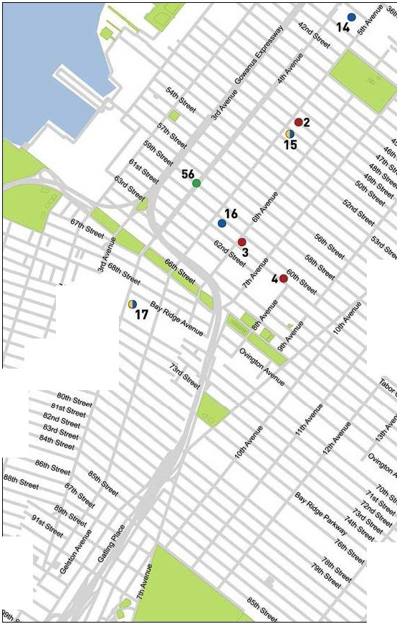

22 •

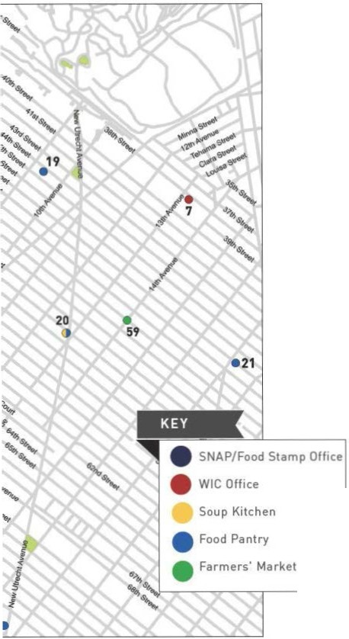


II

'bafr/ Avenue
0
East 39U\ Street east 371.h Street

New Vork.AYMIU8
e..132nd S"""'

0East 31St Street

i
l

Eosl 25\11 StreOI

e..121ms1"'"'
f.3$\ 26th street

E-ast23r<l Street
1

()ee8fl ,,,..nue.

.....
M•
M •'°
eos121s1S•""

eas119tl\S"""'
Eest 19\h Street
c.ast. 1&tt'I sueet

East
\.
M
c
'\
"'
17tt'I
sueet

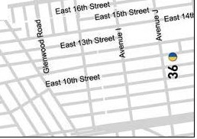
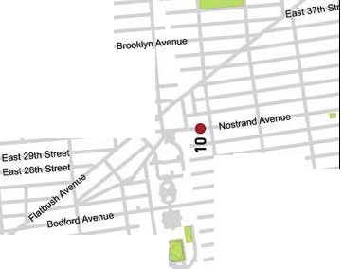
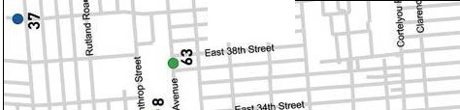
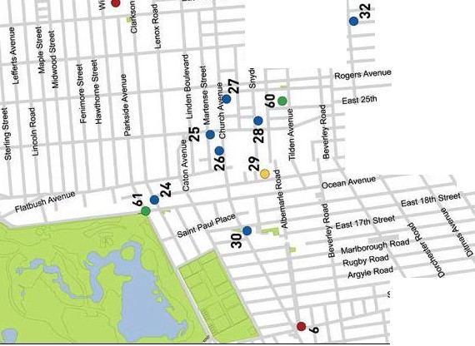

Stratio<dROaO

Eos191l\StI

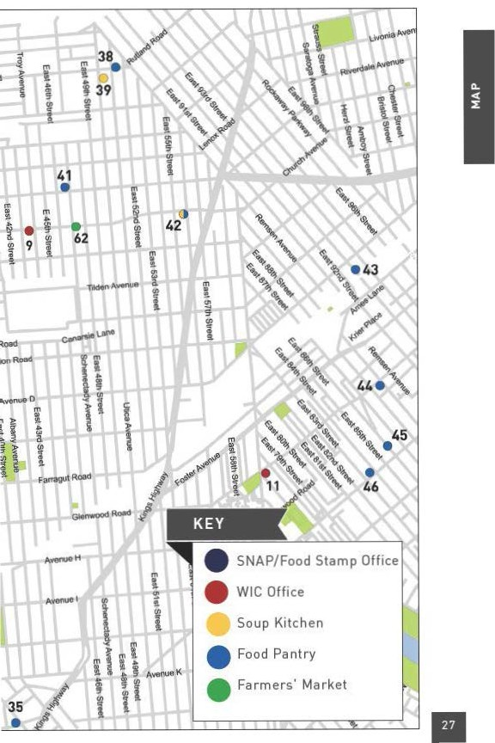

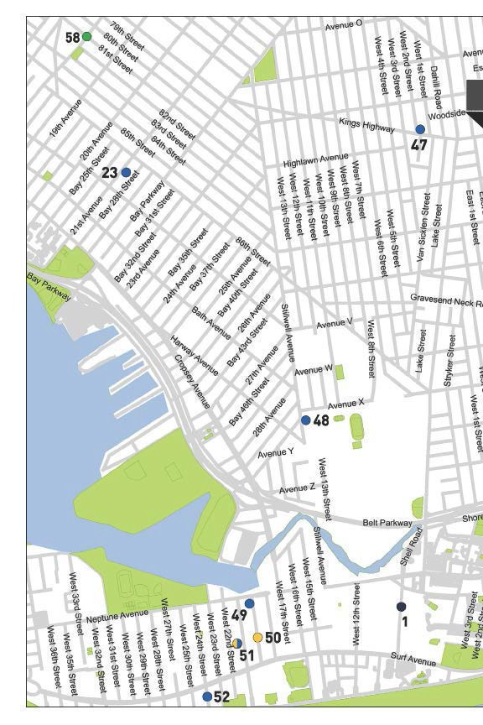

A-..ienu&
E..'z41nStre"'
ea•'i?.nd s"""' ooverSttee'
E... rdS-1
co1erid9" suee•

.(') >

Eas\ t9t" e.ast 16\h Stree\ 1
S\'!'60t
l i
eeau"'°"'Street

Q) l
c u
-t
?:' "'
Q)
Q) ..c

u .B c

"ui

:.,;::
0
a"..'
L.. Q)

•3:
0..

<f>
-0 E
•LL L•"L'

(.) :::J
0 L..

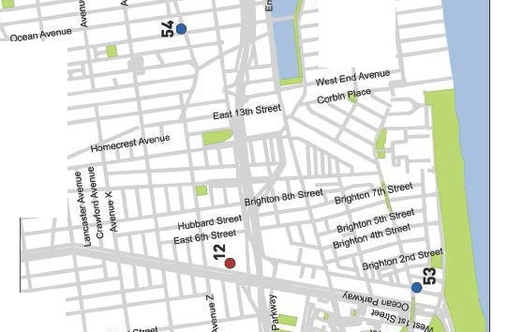
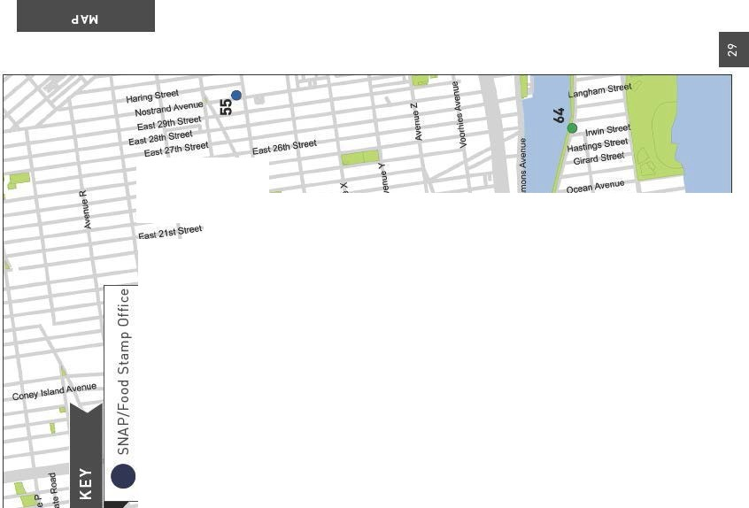
0 0

........?rnt S\f "

OTHER ASSISTANCE
Additional organizations in your neighborhood that can as- sist you with matters other than food support.

MEDICAL CARE

kings County Hospital Center
451 Clarkson Ave., 11203
718 245 3131
Coney Island Hospital
2601 Ocean Parkway, 11235
718 616 3000
Maimonides Medical Center
4802 10 Ave., 11219
718 283 6000
Lutheran Medical Center
150 55 St., 11220
718 630 7000
Homecrest Health Center
1601 Avenue S, 11229
718 616 5102
Ida G. Israel Health Center
2925 W 19 St., 11224
718 692 9540

HEALTH INSURANCE

Affinity Health System
Information regarding health insurance, including enrollment in Medicaid, Medicare and other plans.
General Info 866 694 9809
5221 8th Ave., 11220
857 Flatbush Ave., 11226

Neighborhood Guide to Food and Assistance - Lower Brooklyn edition
30

Provides specific and detailed assistance regarding a wide range of legal topics, including agencies that might be able to help you find an attorney to represent you in court.
LEGAL ASSISTANCE
The City Bar Justice Hotline
212 626 7383
Mon–Thu 9am-5pm, Fri 9am-1pm
Free, basic legal advice on a range of civil issues. Will not provide an attorney or assist with in-court representation.
X
MORE HELP
EMERGENCY NUMBERS

National Hunger Hotline 866 3-HUNGRY (866 348 6479)
NYC Hunger Hotline 866 888 8777 Police, Fire or Ambulance: 911 Emergency Shelter: 311
Homeless Hotline: 800 994 6494, 212 533 5151
Immigration Hotline: 212 419 3737, 800 566 7636
Center for Disease Control: 800 232 4636
Poison Control: 800 222 1222
AIDS Hotline: 800 541 AIDS, 800 233 7432 (Spanish)
Alcoholics Anonymous: 212 647 1680
Narcotics Anonymous: 212 929 6262
Gamblers Anonymous Hotline: 855 222 5542
Domestic Violence Hotline: 800 621 4673
Battered Women Hotline: 718 499 2151
Rape & Sexual Assault Hotline: 212 423 2140, 212 227 3000
Child Abuse Hotline: 800 342 3720
Runaway Hotline: 800 786 2929 (800 RUN AWAY)
Crime Victim Hotline: 212 577 7777, 800 689 4357
Suicide Hotline: 800 273 8255
National Crisis Line: 800 999 9999

Credits: Icons adapted from The Noun Project collection. Map data © OpenStreet- Map contributors.

Neighborhood Guide to Food and Assistance - Lower Brooklyn edition
31
WHAT AM I ELIG IBLE FOR ?

Use the chart below to see what programs may be available for you and your family.
e CD 0


PEOPLE WITH CHILDREN
e 0

PEOPLE WITHOUT CHILDREN
e a> 0

SENIOR CITIZENS
e CD 0

HOMELESS INDIVIDUALS

LEGAL IMMIGRANTS
e CD 0

UNDOCUMENTED IMMIGRANTS
() 0

A SNAP/ Food Stamp 0Groceries at Food Pantries WIC Packages
'1Benefits
School Breakfast & Lunch - Meals at Soup Kitchens
W Free Summer Meals for Children
/IP\ Meals at Senior Centers
\ii Home-delivered Meals
-IU:JN6ER

FREE
NYC
Have any suggestions on how to make this Guide better? Email gu ideslilhu ngerf reenyc.org.

